***GLA 4 – Day 1 SQL Interview –***

***Freddie Sherwood***



*Query* ***2*** *Task* ***1***

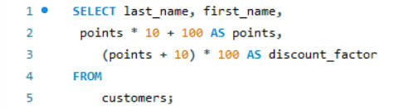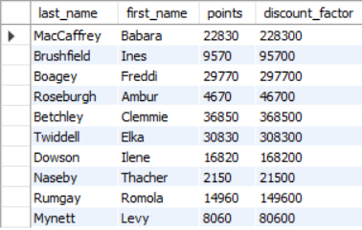

*Query* ***2*** *Task* ***2***

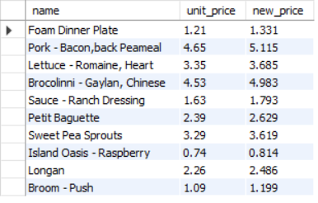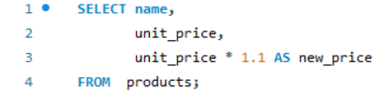

*Query* ***2*** *Task* ***3***

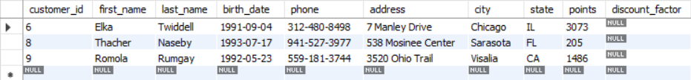

***Query 2 Task 4***

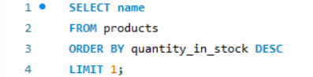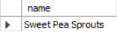

*Query* ***2*** *Task* ***5***

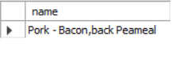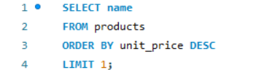

*Query* ***2*** *Task* ***6***

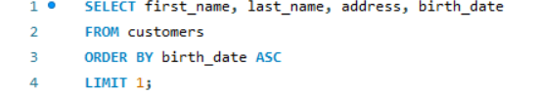

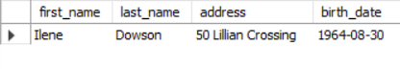

*EER Diagram*

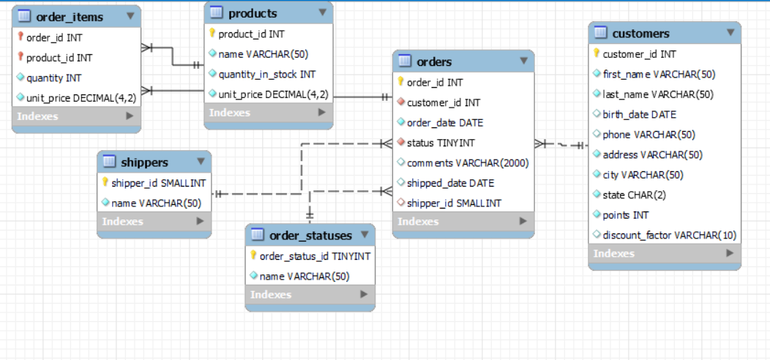

ORDER ITEMS-PRODUCTS

PRODUCTS-ORDERS

ORDERS-CUSTOMERS

ORDERS- SHIPPERS

relates items with products orders

relates products with orders

relates orders with shippers

relates orders with customers

relates orders with order statuses

ORDERS-ORDER STATUSES

displays relations of orders to shippers based on orders made to shippers

displays orders in relation to order status based on order arrivival

displays relations based of customers in relation to orders made

displays relations of products to orders based on orders of products

displays relations based on orders to products

*Question* ***1*** *– What is Query? > a set of instructions written in a query language used to retrieve information*

*Question* ***2*** *– What is the ‘Select’ statement? > a fundamental command used to retrieve data from a database*

*Question* ***3 –*** *What is the ‘Where’ clause? > a command used to extract a record(s) based on fulfilled conditions from columns and rows*

*Question* ***4*** *– What is the Primary Key? > a unique identifier for each entry in a table*

*Question* ***5*** *– What is a Database > an organized collection of structured information or data*

***Second set of Questions***

*Question* ***1 –*** *List the different types of relationships in SQL and give examples.*

*ONE TO ONE -* Consider two tables: users and user_profiles.

Each user has a single corresponding profile.

*ONE TO MANY - Consider two tables: departments and employees. Each department can have multiple employees, but each employee belongs to one department.*

*MANY TO MANY -* *Consider two tables: students and courses. Each student can enroll in multiple courses, and each course can have multiple students.*

*Question* ***2*** *– What is ‘Normalization’?*

*> a process used in database design to organize data attributes efficiently. It involves structuring a database in a way that reduces redundancy and dependency by dividing large tables into smaller, more manageable pieces.*

*Question* ***3 –*** *Modify the following Query to show the population of Germany*

*‘Select population FROM world where name = ‘France’*

*> SELECT population FROM world WHERE name = 'Germany';*

*Question* ***4*** *– Select the Query which gives the name of countries beginning with U.*

SELECT name FROM world WHERE name LIKE '%U'

SELECT name FROM world WHERE name LIKE '%u&'

SELECT name FROM world WHERE name LIKE 'U%'

*> SELECT name FROM world WHERE name LIKE ‘U%’*

*Question* ***5*** *– Select the answer which shows the problem with this SQL code – the intended result should be the continent of France:*

* *SELECT continent FROM world*

*WHERE ‘name’ = ‘France’*

1. *Continent should be continent*
2. *‘name’ should be name*
3. *‘France’ should be France*
4. *‘France’ should be France*
5. *‘France’ should be France*

*> B (‘name’ should be name*

*Question* ***6*** *– Select the code which shows the countries that end in A or L*

*-SELECT name FROM world WHERE name LIKE ‘a%’ AND name LIKE ‘1%’*

*-SELECT name FROM world WHERE name LIKE ‘a%’ OR name LIKE ‘1%’*

*-SELECT name FROM world WHERE name LIKE ‘%a’ AND name LIKE ‘%1’*

*-SELECT name FROM world WHERE name LIKE ‘%a’ OR ‘1%’*

*-SELECT name FROM world WHERE name LIKE ‘%a’ OR name LIKE ‘%1’> SELECT name FROM world WHERE name LIKE ‘%a’ AND name LIKE ‘%1’*

*Question* ***7*** *– Given the table on the left, select the query which produces this table below.*

SELECT name, population FROM world WHERE population BETWEEN 1000000 AND 1250000

FROM name, population FROM world WHERE population BETWEEN 1000000 AND 1250000 SELECT world

FROM world

SELECT name,

population

BETWEEN 100OOO

AND 1250000

Region

South Asia

Algeria

Albania

Afghanistan

Area/Population

652225/ 26000000

28728/3200000

2400000/ 32900000

75012000000

6656000000

GDP

Timor-Leste

1066409

1220000

Swaziland

Bahrain

Name

1234571

Population

Name

Europe

Middle East

Andorra

Middle East

468/64000

> SELECT name, population FROM world WHERE population BETWEEN 1000000 AND 1250000

**SQL _Assignment 2 – Freddie Sherwood**

*TASK 2 QUERY 1*

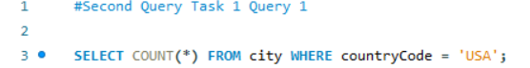



*TASK 2 QUERY 2*

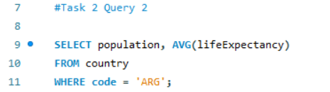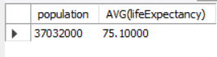

*TASK 2 QUERY 3*

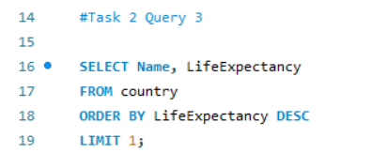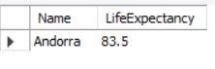

*TASK 2 QUERY 4*

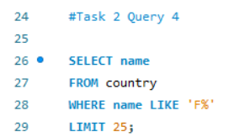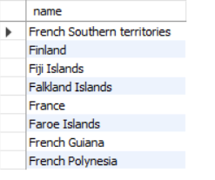

*TASK 2 QUERY 5*

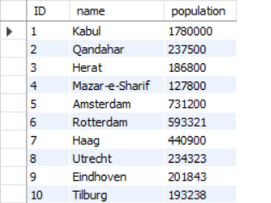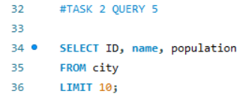

*TASK 2 QUERY 6*

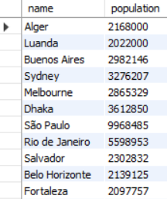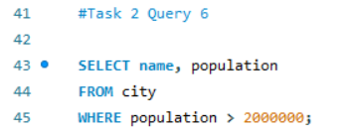

*TASK 2 QUERY 7*

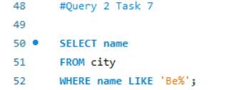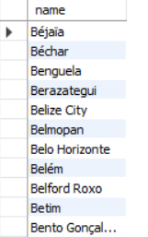

*TASK 2 QUERY 8*

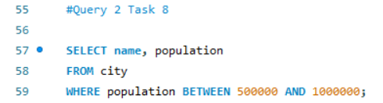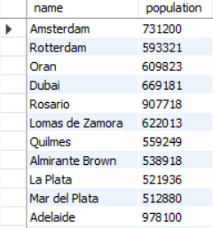

*TASK 2 QUERY 9*

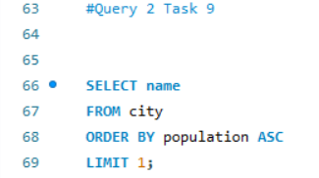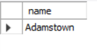

*TASK 2 QUERY 10*

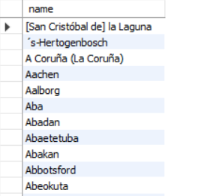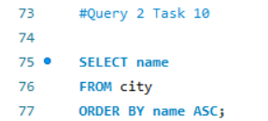

*TASK 2 QUERY 11*

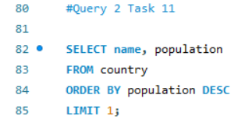

*EER Diagram*

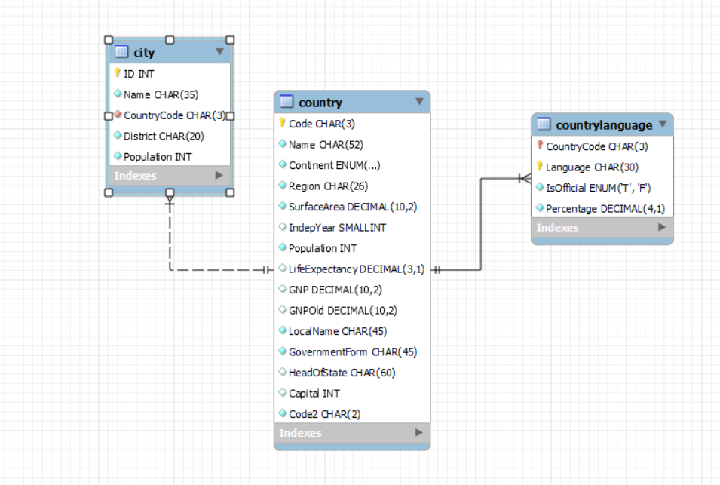

*Primary Key in Country Table - Name*

*Primary Key in City Table - Name*

*Primary Key in CountryLanguage Table - Language*

*Foreign Key in City Table - District*

*Foreign Key in CountryLanguage Table – Country Code*